CURRICULUM VITAE 2022
English Teacher and Author
PERSONAL DATA: Name: Berta Elvira Otero Nationality: Argentinian DOB: 28-01-57 Address: 1084 Eva Perón st. Lanús P. C.: 1824 MPN°: +5491126505468 e-mail address: bertaotero2@gmail.com / info@aprendiendoinglesconpeliculas.com
EDUCATION: Tertiary Degrees: *Teacher of English for EGB 3rd cycle and Polymodal Education. Granted by Instituto Superior Pio XII, Avellaneda district, in December 2008
*Teacher of English for EGB 1st and 2nd cycle. Granted by Instituto Superior de Formación Docente Nª 100, Avellaneda district, in July 2005
Secondary Qualification: * Bachiller Nacional. Granted by Escuela Normal Superior Nacional Mixta, Próspero Alemandri de Avellaneda.
LITERARY WORKS: I am the author of the ESL activity book (and e-book): ‘Learning English with movies, David Copperfield’, based on the movie: ‘David Copperfield’, registered as an unpublished book in November 2019. And self-published in June 2021. ISBN: 9789878030982
Moreover, I have transcribed many movies’ scripts to be used as resources in the English language teaching.
SPECIALIZATION STUDIES: * Teacher training course: ‘Business English for teachers’, granted by On Target Institute, in 2011(duration 8 months, via e-learning).
*Majoring Course: ‘Pedagogy of the English Language Phonology -module 1’, granted by Universidad Nacional de San Martín (UNSAM), in 2010 first semester.
*Majoring Course: ‘Pedagogy of the English Language Phonology -module 2’, granted by Universidad Nacional de San Martín (UNSAM), in 2010 second semester.
EMPLOYMENT EXPERIENCE:
*From May 2008, to March 2014, I have worked as an English teacher in Instituto Educativo Argentino (IEA) Teaching English to higher education students in the courses of Hospitality Management; Tourism; Public Relations, Environmental Health and Safety, and Foreign Trade.
*From February 2014 to the present I have worked in 2 Inspection Companies (Oil Test Internacional de Argentina and Oil Quality) teaching Business English to their executive and administrative staff and technical English to their surveyors. I have also assisted the companies in translations, interpretation in audits in English, preparing surveyors for the agri IFIA exam in English, and counselling in language matters.
*At present, I belong to the consultancy-teacher staff of the online English teaching international platform: https://englishtrainers.org with its headquarters in Hamburg, Germany. You can read my profile by clicking this link: https://www.englishtrainers.org/user/berta+otero
*For more than 40 years I have worked as a private teacher, home tutor, giving support on English to many students. From 2021 onwards, I have taught retired people via zoom, for free.
*On February 11th 2022, I have been interviewed about my work as an ESL teacher and an author at Jeff Buck’s Language Learning’s Youtube’s channel. Here is the Youtube’s link to the interview: https://www.youtube.com/watch?v=QLMdHembXcw
*From February 14th to April 29th, 2022, I have conducted a 2-week-online workshop on ‘Literature and Films’ for intermediate and advanced ESL students, organised by Bhupal Nobles University, Udaipur, Rajasthan, India.
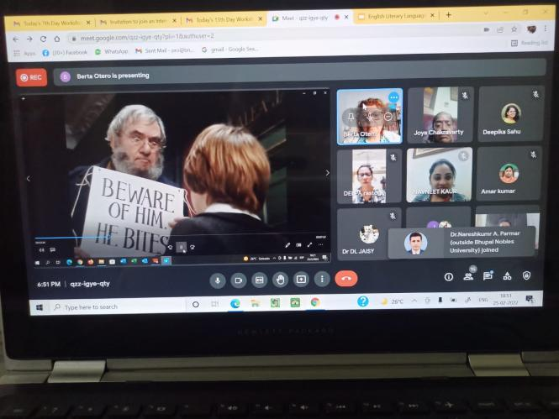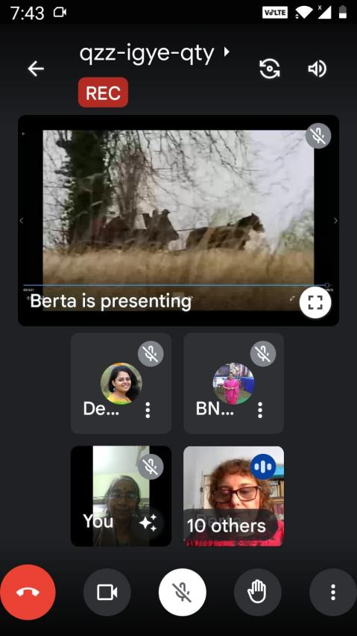
*On May 7th, 2022, I have participated in an Online English Session called:‘English Dickens’ Literature brought to The Big Screen, New ways to teach English through movies’, organised by Azis Soubai at Everyone Academy, an education Moroccan platform that encourages online collaboration among individuals -teachers, educators, students- . Here it is the Youtube’s link to the promoting talk: https://youtu.beUexx/gGslysM
* From March 2022 to the present I have worked as an ESL face-to-face teacher in Instituto Top Notch in Lanús for the kinder level course.
*From March 2022 onwards, I have been doing voluntary teaching for pensioners and people in general teaching English for free at Centro de Jubilados Unidos Por La Lucha, located in my neighbourhood.
WORKING CONDITION: Monotributo taxpayer
INTRESTS: It is my wish to be able to continue writing educational English books to contribute in the teaching of the English language. I love being an English instructor of any kind of students. I also love culture in general, history, geography, literature and travels.
SKILLS: *Spanish language -native speaker competence; *I. T. skills; *Radio announcer; *Italian language, intermediate level
SOCIAL MEDIA PROFILES: *Facebook: Berta Otero *Instagram: berta.otero73 *LinkedIn: Berta Otero *Web page: https://aprendiendoinglesconpeliculas.com/en
https://aprendiendoinglesconpeliculas.com

